This is a listing of all the chi books that are in our library along with any comments I feel is important about each one. Every book has its good points and is worth getting if you can find it at a decent price. Most of these books can be found on Amazon.com Marketplace and others on ebay.com. Some are good for all owners while others would be more for the ones that plan on breeding.
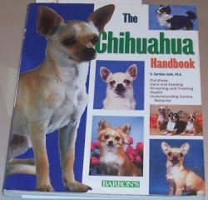 | The Chihuahua Handbook  by D. Caroline Collie, Ph D.  Barrons Press 2000  This is my favorite chi book, covers alot of topics and even makes genetics easy to understand!
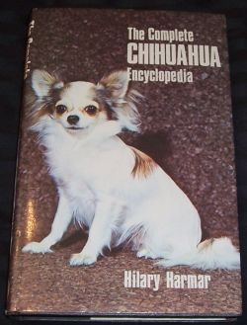 | The Complete Chihuahua Enclyopdeia  by Hilary Harmar  It has good sections on breed development, however other sections are dated and most of the showing is from a UK standpoint. A good book for a chi book collection, but a bit pricey unless you just have to have it.
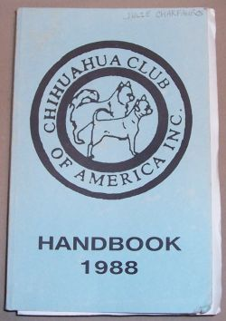 | The Chihuahua Club of America Handbook, 1988  This is a excellent book to have on hand if you plan to breed, and it is the first handbook put out by the CCA. Includes Speciality results from 1935, CCA presidents, Where did the Chihuahua come from?, What is the CCA?, Twenty breeding principles, Chihuahuas as living art, Part if the Chihuahua, Conformation faults, The Chihuahua bite, Down memory lane and the Molera, Some thoughts on Breeding, thoughts on whelping and care of new pups, info on the standard (at the time of publication), show results, top producers, Best in Show, Basics of Handling, Obedience and Chihuahuas, and After the wins. Next, on pages 50 - 330 are the pedigree pages! These include photos of some chihuahuas along with a 3 generation pedigree! other info includes the owner, breeder, sex, color and birthdate. Pages 331 - 439 are advertising. There is no index in this edition, however there are a few folded pages not attached to the book that names of the owenrs so you know where to look for a specific kennel.
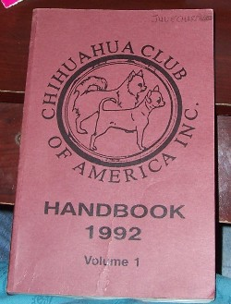 | The Chihuahua Club of America Handbook, 1992, Volume 1  This is a excellent book to have on hand if you plan to breed. It has National breed Speciality results from 1935 -1991, Best in Show updates, group winning chis, CCA presidents, Parts of the chihuahu and the breed standard, revised breed standard, Top producers, 1979-1991, Chihuahua sires of 12 or more CHs, 1/79 - 12/91, Chihuahua dames of 6 or more CHs, 1/79 -12/91, After the Wins, Winners/Producers of Winner 1958-1991, Food for thought on breeding/exhibiting chihuahuas, Chihuahuas in the toy group, Thoughts from a Novice (on breeding and showing chis), Helping puppies develop to their greatest potential and helpful hints, grooming the chihuahua, the obedience-trained chihuahua, Chihuahuas in the UK, Showing Chihuahuas in Europe and chihuahuas in the Netherlands, Chihuahuas in Norway, Remembrances, History of the chihuahu as traced through Precolumbian Artificats and the pedigree pages start on page 82 - 320 and include photos, 3 generation pedigree, birthdate, sex, breeder and owner. To be used with Volume 2, see below.
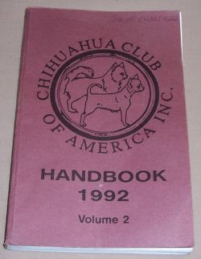 | The Chihuahua Club of America Handbook, 1992, Volume 2  This is a excellent book to have on hand if you plan to breed. It starts on page 321 and starts on the pedigree section pages which go to 469. Pages 470 - 594 are advertising and wrapping up is an index by dogs and also by breeders/owners.
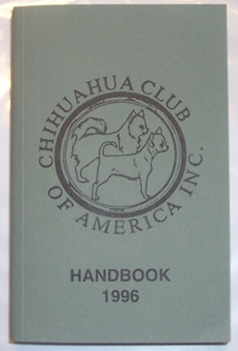 | The Chihuahua Club of America Handbook, 1996  This is a excellent book to have on hand if you plan to breed. Includes info on the standard (at the time of publication), show results, top producers, new colors, molera info, the chihuahua is a chihuahua (info on the term "teacup"), rememberance of Kay Darrah, breed resuce, chihuahuas both sides of the atlantic, the chihuahua: a closer look (this is a GREAT article with illustraions describing the standard), the 'kel tal-but' of chihuahuas in Malta and sociologically speaking. Next, on pages 67 - 470 are the pedigree pages! These include photos of some chihuahuas along with a 3 generation pedigree! other info includes the owner, breeder, sex, color and birthdate. Some pages even inclde the weight. Pages 471 - 617 are advertising and wrapping up is an index by dogs and also by breeders/owners.
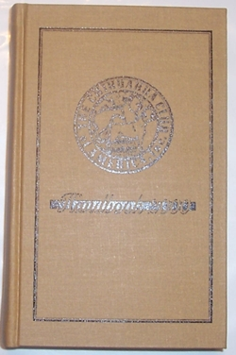 | The Chihuahua Club of America Handbook, 2000  This is a excellent book to have on hand if you plan to breed. Includes info on past CCA presidents, specialty results, top producers, chihuahuas in obedience and agility, the standard (at the time of publication), a rough road rescue, chihuahuas chihuahuas chihuahuas chihuahuas everywhere (effects of the taco bell dog craze), and early chihuahua history. Next, on pages 46 - 393 are the pedigree pages! These include photos of some chihuahuas along with a 3 generation pedigree! other info includes the owner, breeder, sex, color and birthdate. Some pages even inclde the weight. Pages 394 - 526 are advertising and wrapping up is an index by dogs and also by breeders/owners.
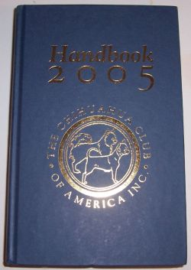 | The Chihuahua Club of America Handbook, 2005  This is a excellent book to have on hand if you plan to breed. In Loving Memory Tanya Y Delaney, Acknowledgments, Officers, info on Past Presidents, Show results, top producing sires and dames, The Cultivation of a Show Dow, Chihuahua Resuce in the US, Sportsmanship and Mentorship Among CCA Members. Next on pages 73 - 368, are the pedigree pages! These include photos of some chihuahuas along with a 3 generation pedigree! other info includes the owner, breeder, sex, color and birthdate. Some pages even inclde the weight. Then we have History of the Chihuahua, Offical Standard (at the time of publication). Pages 389 - 464 are advertising and wrapping up is an index by dogs and also by breeders/owners.
 | Chihuahua Champions 1984-2004  Camino Books  This is a excellent book to have on hand if you plan to breed. It has a few articles: Training your Toy Breed Dog, Nurse Dog, About Abby, Beta-carotine: Boosting Your Dog's Immune System, C-Sections, does your bitch need one, Spunds...the unlikely agility Star!. Pages 23-62 are color photos of Champions and Titleholders and the rest of the book is a breakdown of names and inclues Top producing sires and dames, and sires and dames of champions.
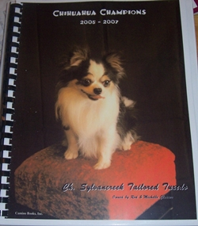 | Chihuahua Champions 2005-2007  Camino Books  Another great resource for the breeder or show owner! Articles in this edition include What to Know about a Dog's Family Tree, Chihuahuas-- Any Color [Breed] Marked or Splashed (article on the merle coloration), Chihuahuas and Children, and Finding a Lost Dog. Pages 14-69 are color photos of Champions and Titleholders and the rest of the book is a breakdown of names and inclues Top producing sires and dames, and sires and dames that have produced champions, listed with the CH offspring.
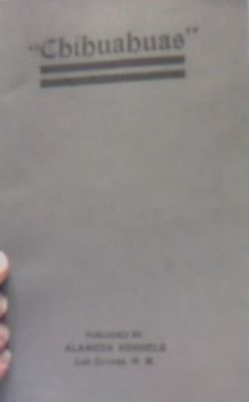 | Chihuahuas, 1922, Reprint 1980  Walter Johnson  Alameda Kennels  This is a great book to find and add to any chihuahua collection if you can find a copy or reprint. A note in the reprint said there is only two know originals left! It is a compilation from the authors scrapbook and dedication to the breed. Even has some old ads in there too!
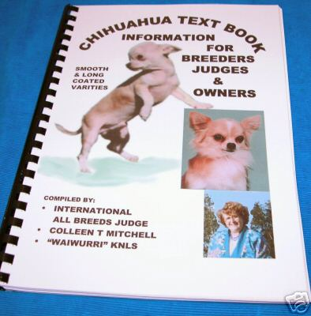 | Chihuahua:  A Textbook for Breeders and Judges  by Colleen T Mitchell  2005  You have to look for this one on Ebay. Incudes info on  THE HISTORY OF THE BREED  TRADITIONS  RESPONSIBLE BREEDING PRESENTATION TIPS  A VASTLY EXTENDED STANDARD  HOW TO CHOOSE A PUPPY TO KEEP  HOW TO OBSERVE & JUDGE WHAT YOU SEE & FEEL AND MUCH MORE
Chihuahuas
by Susan Payne
2009
This one is brand new, I am waiting for it to come in.
More info will be posted soon, can be ordered on Amazon.com
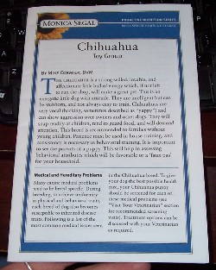 | Chihuahua:  Proactive Nutrition Series  by Monica Segal  Triadicon 2007  This isn't a book, but a phamplet that talks about medical conditions in the chihuahua such as hemophilia A, Peridontitis, cleft palate, portosystemic (liver) shunt, corneal dystrophy, Entropion, glaucoma, dry eye, iris atrophy, lens kuxation, PRA, hypothyroidism, mitral valve defects, pulmonic stenosis, hypoglycemia, osteochondrosis dessicans, patellar luxation, hydrocephalus, hypoplasia of dens, open fontanel (molera), color mutant alopecia, demodicosis, pattern baldness, collapsed trachea and cystine uroliths. Also inculded are questions for the breeder and vet. the second half of this is broken into sections (heart health, Oral health, eyes, hypoglycemia, hypothyrodisim, urinary tract) along with proactive health tips to keep those area in great shape.
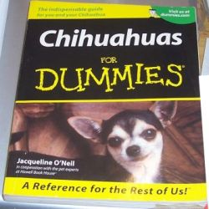 | Chihuahuas for Dummies  by Jacqueline O'Neil  IDG Books 2001
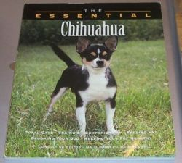 | The Essential Chihuahua  Edited by Ian Dunbar, Ph D.  Howell Book House 1999
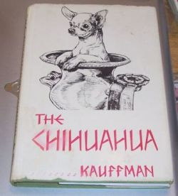 | The Chihuahua  by Rev. Kauffman  Judy Publishing, 1959  This book is believe to  be the work of the late  Ida Garrett
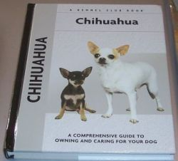 | Chihuahua: A Kennel Club Book  by Barbara J. Andrews  Kennel Club Books, 2004  This is another really good book. The history section is very good and it has illustration to show things such as correct and incorrecthead shape, tail carriage, ear set etc. It even has a place in the back to keep all of your important dog info.
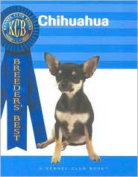 | Chihuahua: Breeders Best  by Ann Hearn  Kennel Club Books, 2004
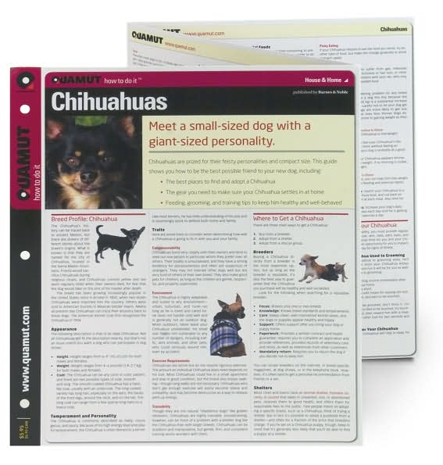 | Chihuahua: Quamut Series  published by Barns and Noble, 2007  This is a tri-fold pamphlet nice for a quick referance
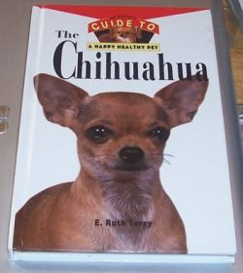 | The Chihuahua, A Happy Healthly Pet  by E. Ruth Terry  Howell Book House, 1996  Part one of this book is good, however part two is generalized to dogs, not chi specific.
 | The Chihuahua, A Happy Healthly Pet, 2nd Edition  by Elaine Waldorf Gewirt  Howell Book House, 2006  Part one of this book is good, however part two is generalized to dogs, not chi specific.
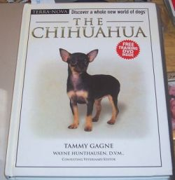 | The Chihuahua  by Tammy Gagne, Wayne Hunthausen, D.V.M., Consulting Veterinary Editor  THF Publications, 2006
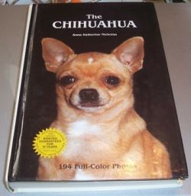 | The Chihuahua  by Anna Katherine Nicholas  THF Publications, 1988  This is another good book to have as it has lots of photos of previous champions and talks about Kennel development of most of the early prestgious lines. If you have a well bred dog and trace the pedigree back you will probably find photos of your dogs relatives in this book.
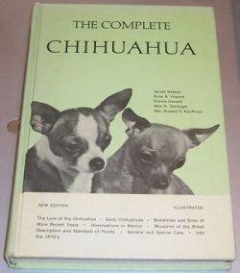 | The Complete Chihuahua  James Watson  Anna B. Vinyard  Rosina Casselli  Milo G. Denlinger  Rev. Russell E. Kauffman  Howell Book House, 1971
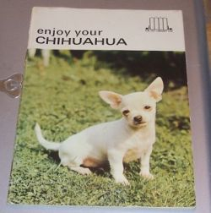 | Enjoy your Chihuauha  Earl Scheider, Editor  The Pet Library, 1967  This is a short 32 page booklet on the chi.
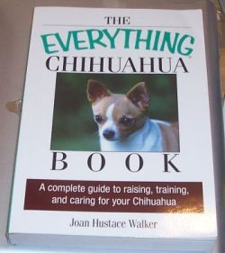 | The Everything Chihuahua Book  by Joan Hustace Walker  Adams Media, 2006  This book is great, however it does not mention breeding or coat color genetics or some of the issues that can arise with the reproductive organs (cryptos or pyometera) so falls short of an "Everyting" book, but for the average owner would be great.
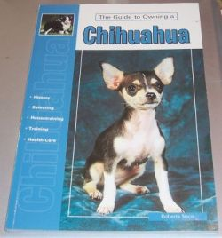 | The Guide to Owning a Chihuahua  by Robert Sisco  THF Publications, 2003.
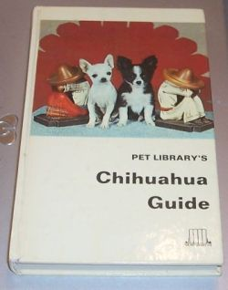 | Pet Library's Chihuahua Guide  Hilary Harmar  The Pet Library, 1968  This is basically a condensed version of the Chihuahua Encloypedia.
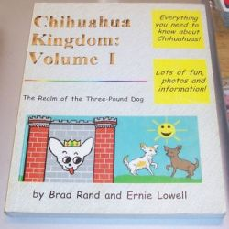 | Chihuahua Kingdom Vol 1  by Brad Rand and Erniw Lowell  Self-Published  While hard to find, this is one of the best books out there. There was supposed to be a second volume, but I have yet to find it.
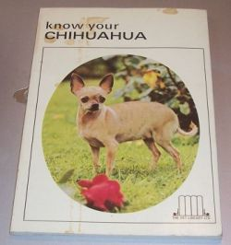 | Know Your Chihuahua  Earl Schneider  The Pet Library, not date printed  This is an older book, I found 1967 on one website as the DOP, the intresting thing is this book mentions merles in the color inhertance section!
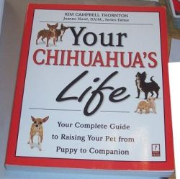 | Your Chihuahua's Life  Kim Campbell Thorton  Prima Pets, 1999
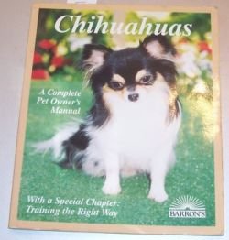 | Chihuahuas A Complete Pet Owners Manual  D. Caroline Colie, Ph.D.  Barrons, 1995
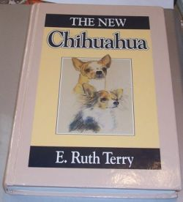 | The New Chihuahua  by E. Ruth Terry  Howell Book House, 1990  This is another great book for breeders as it has lots of photos of champions in it.
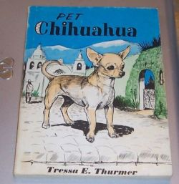 | Pet Chihuahua  Tressa E. Thurmer  All Pets Books Inc, 1959
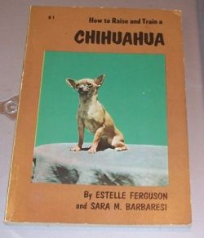 | How to Raise and Train a Chihuahua  Estelle Ferguson and Sara M. Barbaresi  TFH Publications, 1958
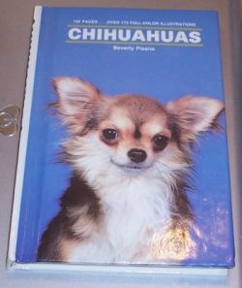 | Chihuahuas  by Beverly Pisano  TFH Publications, 1990.
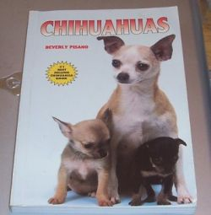 | Chihuahuas  by Beverly Pisano  TFH Publications, 1995
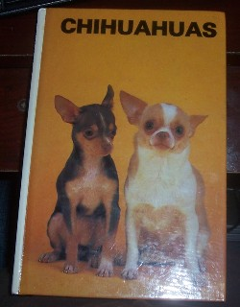 | Chihuahuas  by Beverly Pisano  TFH Publications, 1983
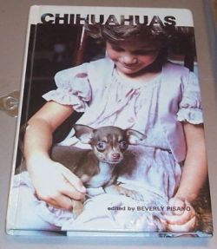 | Chihuahuas  by Beverly Pisano  TFH Publications, 1980
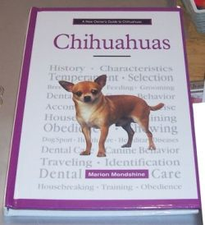 | Chihuahuas  by Marion Mondshine  TFH Publications, 1998
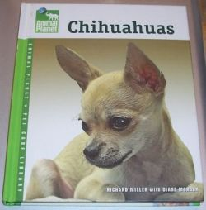 | Chihuahuas  by Richard Miller  TFH Publications, 2006
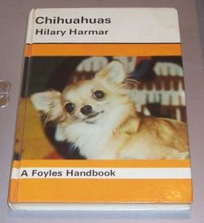 | Chihuahuas  Hilary Harmar  Foyles, 1966
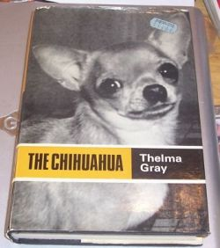 | The Chihuahua  by Thelma Gray  Arco, 1961
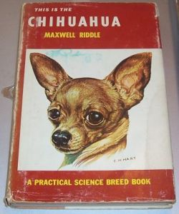 | This is the Chihuahua  Maxwell Riddle  TFH Publications, 1959
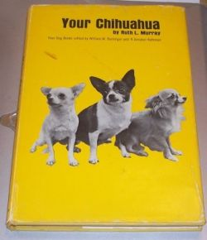 | Your Chihuahua  by Ruth L Murrary  Hawthorn, 1966
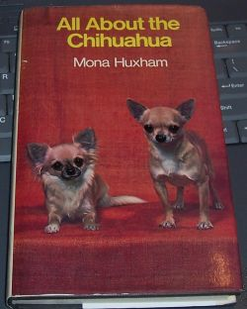 | All about the Chihuahua  by Mona Huxham  Pelham Books, 1976
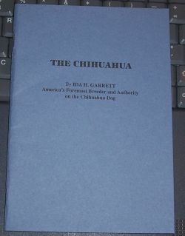 | The Chihuahua  by Ida Garrett  Louis Minsky Publishing, 1933  This is said to be the second book ever published on the chihuahua.
 | Chihuahuas  By Beverly Piscano  TFH Publications, 1995
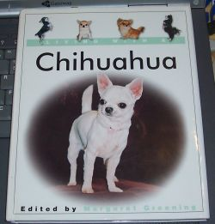 | Living with a Chihuahua  By Margaret Greening  Barrons, 2003
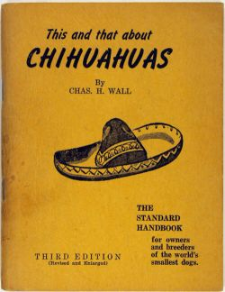 | This and That About Chihuahuas  By Chas Wall  Buddy Press, 1956
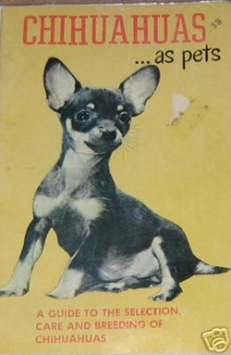 | Chihuahuas as Pets  by Madeline Miller  1955
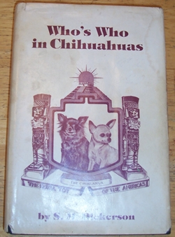 | Who's Who in Chihuahuas  by SM Dick Dickerson  1979  This is a great book that shows popular breeders, tells about them and show pics of some of CH's before 1979. A great referance for anyone intrested in pedigree work, however hard to find!

